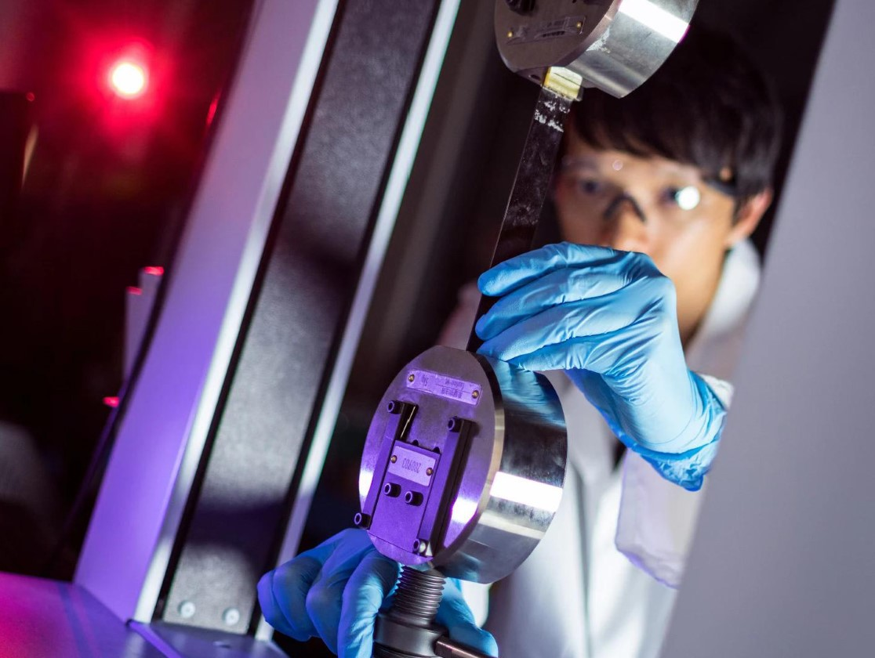

Thermo Lab
2900097

Methods
  - Apparatus
- Syringe
- Syringe cap
- Vernier calliper’s
- Multi-meter
- Thermal couple
- Lab book and pen
- Water
- Kettle
- Mug
- Cold water with ice

  - Procedure
- Measurements: The syringe was separated into both of its components, and the internal barrel diameter was measured. The plunger was then reinserted and compressed to zero volume where the offset was measured allowing for calculation of the displacement.
- Room Temperature Test: The syringe was filled with 40 mL of room air to allow for space when the air is both compressing and expanding. The nozzle was sealed using the syringe cap to ensure no air is lost or gained. The initial distance between the top of the plunger and the top of the barrel was recorded as well as the room temperature using the thermocouple.
- Hot and Cold Tests:
  - Hot Environment: Boiled water was poured into the heat-resistant container. The syringe and the thermocouple probe were fully submerged into the container. The syringe was allowed to sit until the temperature remained constant as shown by the multi-meter screen. The equilibrium water temperature and the inner distance between both parts of the syringe were recorded.
  - Cold Environment: The syringe and thermocouple were placed into an ice-water bath. Once the temperature was constant, both the inner distance between both parts of the syringe and the temperature were recorded.
  - Steps 2 and 3 were repeated for a total of 3 measurements per environment to ensure repeatability and reduce random error

Results
The experiment measured the syringe barrel length and how it changed in 7 different environments. The below equations were used to convert from degrees centigrade to kelvin and syringe barrel length to displacement respectively.
Temperature in Kelvin = Temperature in degrees centigrade + 273.15 [1]
Displacement = Syringe barrel length – 12.6 [2]
Table 1: Table of Results
Environment | Room Temp | Hot 1 | Hot 2 | Hot 3 | Cold 1 | Cold 2 | Cold 3
Temperature (°C) | 20 | 88 | 91 | 89 | 5 | 6 | 7
Temperature (K) | 293 | 361 | 364 | 362 | 278 | 279 | 280
Displacement (mm) | 73.8 | 81.8 | 82.5 | 82.4 | 72.7 | 72.4 | 72.4

Using a measurement of 12.6mm for the internal radius of the syringe drum the displacement values were converted to volumes using the equation below.
$V= ∆xπr^{2}$ [3]
where V is the volume, $∆x$ is the displacement, and r is the internal radius of the syringe drum
Finally, using the equation below and the relationship between volume and temperature an estimate of the specific gas constant of air, R
$V=\frac{mR}{P}T$ [4]
where V is the volume, m is the mass, R is the specific gas constant, P is the pressure, and T is the temperature
We calculated the gradient of the Temperature vs Volume graph shown in figure 4 to be $1.34 × {10}^{-7} m^{3}K^{-1}$. Using equation 4 alongside known values for atmospheric pressure of 101325 Pa and a calculated value for the mass of the air within the syringe to be $5.02 × {10}^{-5}$ kg we can then calculate the value of the gas constant to be 270.4 $JK^{-1}{mol}^{-1}$.

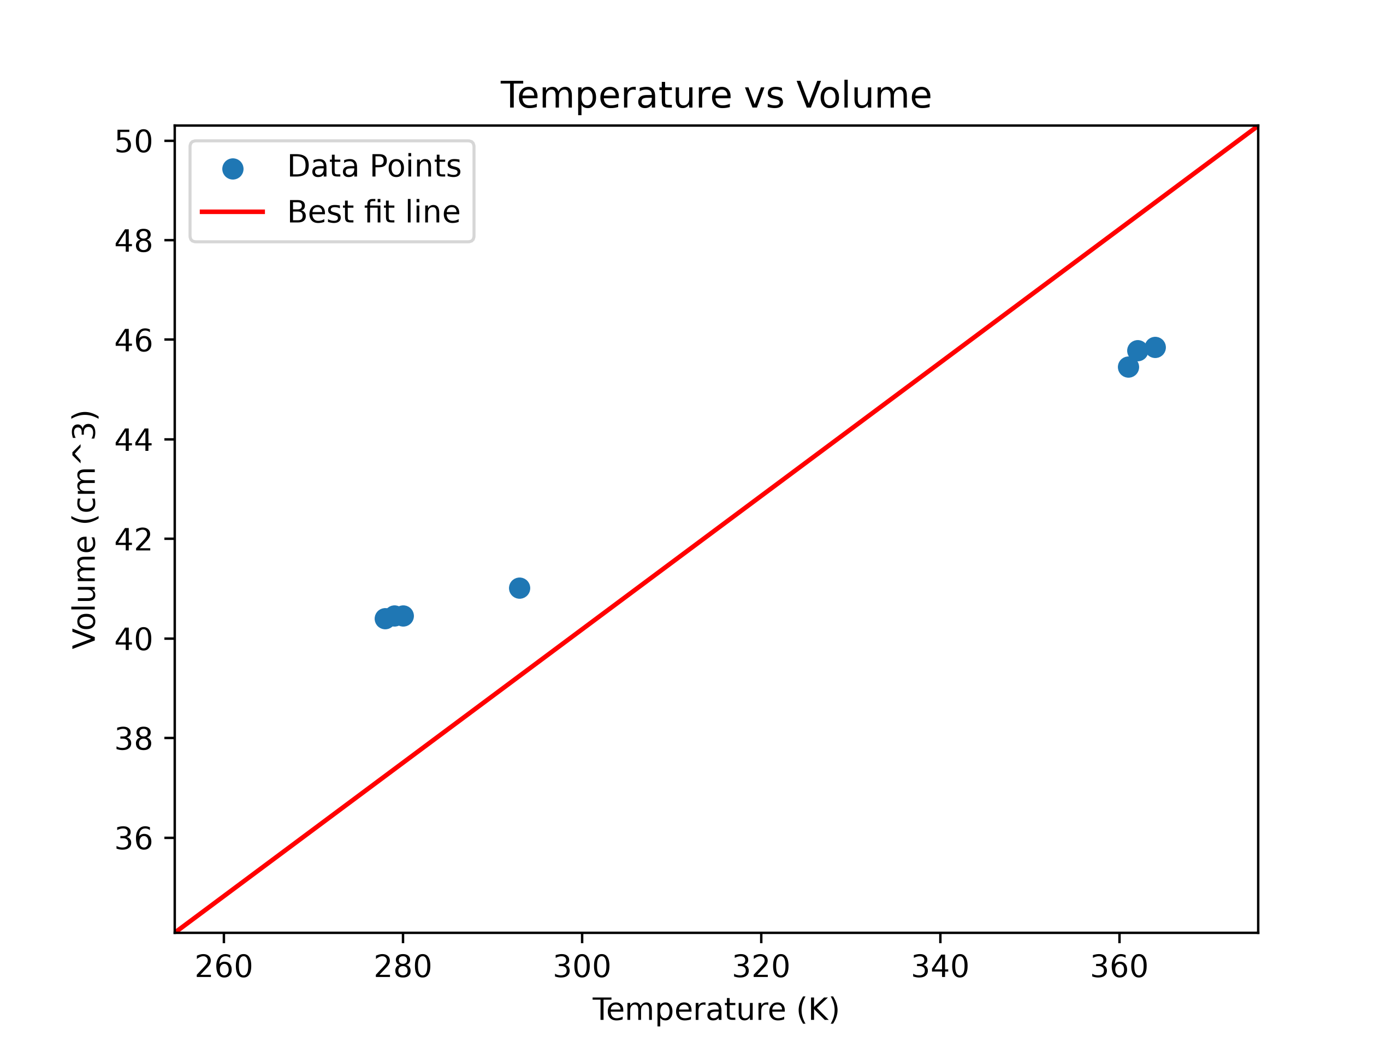
Figure 1: Graph of Temperature against Volume

